Software Requirements Specification
Venue Management System – Venue Listing & Booking Web Application
Project: Venue Management System (VMS) – A Spring Boot and MySQL Web Application for Venue Listing and Booking
Prepared by: Rajneekant Yadav, B.Tech CSE (2024–2028), Department of CSE, ABES Engineering College, Ghaziabad (affiliated to Dr. A.P.J. Abdul Kalam Technical University, Lucknow)
Programme: HCL Industry Training Program, 2026
Standard followed: IEEE Std 830-1998 (Recommended Practice for SRS)
Version: 1.0

1. Introduction

1.1 Purpose
This document specifies the software requirements for the Venue Management System (VMS), version 1.0. It defines what the system must do, the constraints it must work under and the quality attributes it must meet. The intended readers are the project guide and evaluators, the developers (implementation), testers (validation against Section 3 and Section 5) and any future maintainers. It serves as the agreed baseline for design, implementation and testing.

1.2 Scope
VMS is a web application that lets an organisation owning or managing several event venues (banquet halls, lawns, conference rooms) publish those venues and accept bookings for a specific date and time.
The system will:
- allow administrators to add, view, update and delete venues and to confirm or cancel bookings;
- allow customers to register, log in, browse venues and book a venue for a date and time slot;
- automatically reject any booking that overlaps an existing non-cancelled booking of the same venue (double-booking prevention); and
- record a payment entry for every booking and expose all features through RESTful JSON APIs.
The system will not, in version 1.0, provide a complete graphical frontend, token-based authentication (Spring Security/JWT), online payment-gateway integration or a mobile application (see Appendix B).

1.3 Definitions, Acronyms and Abbreviations
Term | Meaning
SRS | Software Requirements Specification
REST / API | Representational State Transfer / Application Programming Interface
JPA / ORM | Java Persistence API / Object-Relational Mapping (implemented by Hibernate)
JSON | JavaScript Object Notation, the data format of all requests and responses
Admin / Customer | The two user roles (ADMIN, CUSTOMER) supported by the system
Booking status | PENDING, CONFIRMED or CANCELLED
Double booking | Two active bookings of the same venue whose time slots overlap on the same date
FR / NFR | Functional / Non-Functional Requirement

1.4 References
- IEEE Std 830-1998, IEEE Recommended Practice for Software Requirements Specifications (structure followed).
- Venue Management System – Project Report, HCL Industry Training Program, ABES Engineering College, 2026.
- Spring Boot, Spring Data JPA, Hibernate and MySQL 8.0 official documentation.

1.5 Overview
Section 2 describes the product in general terms: its context, functions, users and constraints. Section 3 lists the functional requirements by feature. Section 4 covers external interfaces, including the REST API, Section 5 the non-functional requirements, and Section 6 the data requirements. Section 7 holds appendices.

2. Overall Description

2.1 Product Perspective
VMS is a new, self-contained, server-side product that replaces manual registers, phone calls and site visits. It follows a four-layer architecture in which each layer talks only to the layer below it:
- Controller layer: receives HTTP requests and returns JSON.
- Service layer: holds business logic such as time validation and conflict checking.
- Repository layer: Spring Data JPA interfaces that perform database operations.
- Entity layer: maps Java classes to MySQL tables.
An embedded Tomcat server hosts the application, and MySQL stores all data.

2.2 Product Functions
Module | Main functions
User Management | Registration, login and role-based access (ADMIN / CUSTOMER)
Venue Management | Create, read, update and delete venues with location, capacity, price and description
Booking Management | Create bookings, validate time and capacity, prevent double booking, view bookings, confirm or cancel
Payment Management | Store a payment record (amount, status, date) for each booking

2.3 User Classes and Characteristics
User class | Responsibilities | Expected skill
Administrator | Staff of the organisation managing venues: manage venues; view all bookings; confirm or cancel bookings; record payments | Comfortable with web/API tools
Customer | General public planning an event: register/login; view venues; create bookings; view and cancel own bookings | No technical knowledge assumed

2.4 Operating Environment
- Hardware: Intel Core i3 / Apple M1 or equivalent processor; 8 GB RAM; 2 GB free storage; internet access to download Maven dependencies.
- Operating system: macOS, Windows or Linux.
- Runtime / framework: JDK 17 or above (developed on JDK 25); Spring Boot 4.1.1; Apache Maven with Maven Wrapper.
- Database: MySQL Server 8.0 (schema venue_db).
- Development tools: IntelliJ IDEA (Eclipse also supported); Postman or a web browser for API testing; MySQL Workbench.

2.5 Design and Implementation Constraints
- The backend shall be written in Java using Spring Boot, Spring Web (MVC), Spring Data JPA, Hibernate and HikariCP for connection pooling.
- All packages shall reside under the base package com.hcl.Venue_Management so that component scanning works.
- Database tables shall be generated by Hibernate from entity classes (spring.jpa.hibernate.ddl-auto=update).
- Client–server communication shall use HTTP with JSON payloads; the server listens on port 8080 by default.

2.6 Assumptions and Dependencies
- A MySQL 8.0 instance is installed, running and reachable at localhost:3306 with valid credentials.
- Each booking is for a single venue on a single calendar date, with start and end time on that date.
- Venue pricing is per day (price_per_day); the payment amount is supplied when a payment is recorded.
- Maven dependencies can be downloaded from an unrestricted network at build time.

3. System Features (Functional Requirements)
Each feature lists its priority, a short description and numbered requirements. “Shall” marks a mandatory requirement. Priority is High (H), Medium (M) or Low (L).

3.1 User Management and Authentication (Priority: High)
Visitors register and log in, and every user acts only within one assigned role.
ID | Requirement | Priority
FR-1.1 | The system shall allow a visitor to register by providing name, email and password. | H
FR-1.2 | The system shall reject registration when the email is already registered (email is unique). | H
FR-1.3 | The system shall store passwords in hashed form and never as plain text. | H
FR-1.4 | The system shall allow a registered user to log in with email and password and shall reject invalid credentials. | H
FR-1.5 | The system shall assign every user exactly one role, ADMIN or CUSTOMER, which controls the actions permitted. | H

3.2 Venue Management (Priority: High)
Administrators maintain the venue catalogue that customers browse.
ID | Requirement | Priority
FR-2.1 | The system shall let an administrator add a venue with name, location, capacity, price per day and description. | H
FR-2.2 | The system shall let any user view the list of all venues and the details of a single venue. | H
FR-2.3 | The system shall let an administrator update the details of an existing venue. | M
FR-2.4 | The system shall let an administrator delete a venue. | M
FR-2.5 | The system shall return a “Venue not found” error when a non-existent venue id is requested. | M

3.3 Booking Management (Priority: High)
A customer requests a venue for a date and time slot; the system validates the request and prevents double booking.
ID | Requirement | Priority
FR-3.1 | The system shall let a customer create a booking by supplying venue, event date, start time, end time and number of guests. | H
FR-3.2 | The system shall reject a booking whose end time is not after its start time (“invalid time range”). | H
FR-3.3 | The system shall reject a booking whose guest count exceeds the venue capacity. | H
FR-3.4 | The system shall check for any non-cancelled booking of the same venue on the same date that overlaps the requested slot, using: existing.start < new.end AND existing.end > new.start. If one exists, the booking shall be rejected with the message “venue already booked”. | H
FR-3.5 | When validation succeeds, the system shall save the booking with status PENDING. | H
FR-3.6 | The system shall let an administrator view all bookings and change a PENDING booking to CONFIRMED. | H
FR-3.7 | The system shall allow a booking to be cancelled (status CANCELLED); a cancelled booking shall no longer block its time slot. | H
FR-3.8 | The system shall let a customer view the bookings made by that customer. | M

3.4 Payment Management (Priority: Medium)
Every booking has one payment record; the design allows an online payment gateway to be added later.
ID | Requirement | Priority
FR-4.1 | The system shall store one payment record per booking containing amount, status (PAID or UNPAID) and payment date/time. | M
FR-4.2 | The system shall provide an interface to record a payment against a booking, designed so that an online payment gateway can be integrated later. | M

3.5 Booking Life Cycle
A booking moves through the following states. Only non-cancelled bookings take part in the overlap check.
From | Event / actor | To
(new) | Customer submits a valid, conflict-free request | PENDING
PENDING | Administrator confirms | CONFIRMED
PENDING or CONFIRMED | Cancellation requested | CANCELLED

4. External Interface Requirements

4.1 User Interfaces
The current release is backend-only. All functions are accessed through REST endpoints using Postman or a browser. Thymeleaf is included in the project so that server-side HTML pages can be added; a React.js or Thymeleaf frontend for customers and administrators is planned (Appendix B).

4.2 Hardware Interfaces
No special hardware is required beyond the standard computing environment in Section 2.4.

4.3 Software Interfaces
Component | Interface
MySQL 8.0 | JDBC (jdbc:mysql://localhost:3306/venue_db) with HikariCP pooling and Hibernate as the ORM
Maven | Dependency management and build
Postman / MySQL Workbench | API testing and database inspection

The application exposes the following REST API (JSON over HTTP on port 8080):
Method | Endpoint | Purpose | Access
GET | /api/venues | List all venues | All
GET | /api/venues/{id} | Get one venue | All
POST | /api/venues | Add a venue | Admin
PUT | /api/venues/{id} | Update a venue | Admin
DELETE | /api/venues/{id} | Delete a venue | Admin
POST | /api/users/register | Register a customer | Public
POST | /api/users/login | Log in with email and password | Public
POST | /api/bookings | Create a booking (with overlap check) | Customer
GET | /api/bookings | List all bookings | Admin
GET | /api/bookings/user/{userId} | List one customer’s bookings | Customer
PUT | /api/bookings/{id}/confirm | Confirm a booking | Admin
PUT | /api/bookings/{id}/cancel | Cancel a booking | Customer/Admin
POST | /api/payments | Record a payment for a booking | Admin

Sample request – POST /api/venues
{
"name": "Grand Hall",
"location": "Ghaziabad",
"capacity": 500,
"pricePerDay": 50000,
"description": "Large banquet hall with AC"
}

4.4 Communication Interfaces
- HTTP/1.1 over port 8080.
- Requests and responses use JSON (Content-Type: application/json).

5. Non-Functional Requirements
ID | Category | Requirement
NFR-1 | Performance | The application shall start in a few seconds (observed under 2 seconds) and ordinary API calls shall respond within about 2 seconds under normal load.
NFR-2 | Reliability / Integrity | The overlap check and booking save shall not allow two active bookings of the same venue to overlap. Invalid input shall return a clear error message rather than crash the server.
NFR-3 | Security | Passwords shall be hashed; admin-only operations shall be restricted by role; database credentials shall be kept in configuration, not in source code. Spring Security with JWT and BCrypt is planned.
NFR-4 | Usability | API paths and messages shall be consistent and self-explanatory so that a frontend developer can consume them with little documentation.
NFR-5 | Maintainability | The code shall follow the Controller–Service–Repository–Entity layering with one responsibility per class and standard Java naming conventions.
NFR-6 | Portability | The application shall run unchanged on Windows, macOS and Linux with JDK 17 or above.
NFR-7 | Extensibility | The REST design shall allow a web or mobile frontend, and a payment gateway, to be added without changing the core booking logic.
NFR-8 | Testability | Each API shall be testable independently using Postman or a browser.

5.1 Business and Data Rules
- A user’s email must be unique.
- Every booking must reference an existing user and venue; every payment must reference an existing booking.
- A booking’s guest count must not exceed the venue capacity, and its end time must be later than its start time.
- A cancelled booking no longer blocks its time slot; only non-cancelled bookings take part in the overlap check.
- Data is retained in MySQL between restarts; schema changes are applied automatically by Hibernate.

6. Data Requirements and System Models

6.1 Logical Data Model
The database venue_db contains four tables. A user can make many bookings (1:N), a venue can have many bookings (1:N), and each booking has one payment record (1:1).
Table | Key columns | Purpose
users | id (BIGINT, PK); name (VARCHAR 100); email (VARCHAR 120, UNIQUE); password (VARCHAR, hashed); role (ENUM ADMIN, CUSTOMER) | System users and roles
venues | id (BIGINT, PK, auto-increment); name (VARCHAR 255); location (VARCHAR 255); capacity (INT); price_per_day (DOUBLE); description (VARCHAR 255) | Venues available for booking
bookings | id (BIGINT, PK); user_id (FK → users); venue_id (FK → venues); event_date (DATE); start_time (TIME); end_time (TIME); guests (INT); status (ENUM PENDING, CONFIRMED, CANCELLED) | Venue reservations
payments | id (BIGINT, PK); booking_id (FK → bookings); amount (DECIMAL 10,2); status (ENUM PAID, UNPAID); paid_on (DATETIME) | One payment record per booking

Key relationships: users 1–N bookings; venues 1–N bookings; bookings 1–1 payments.
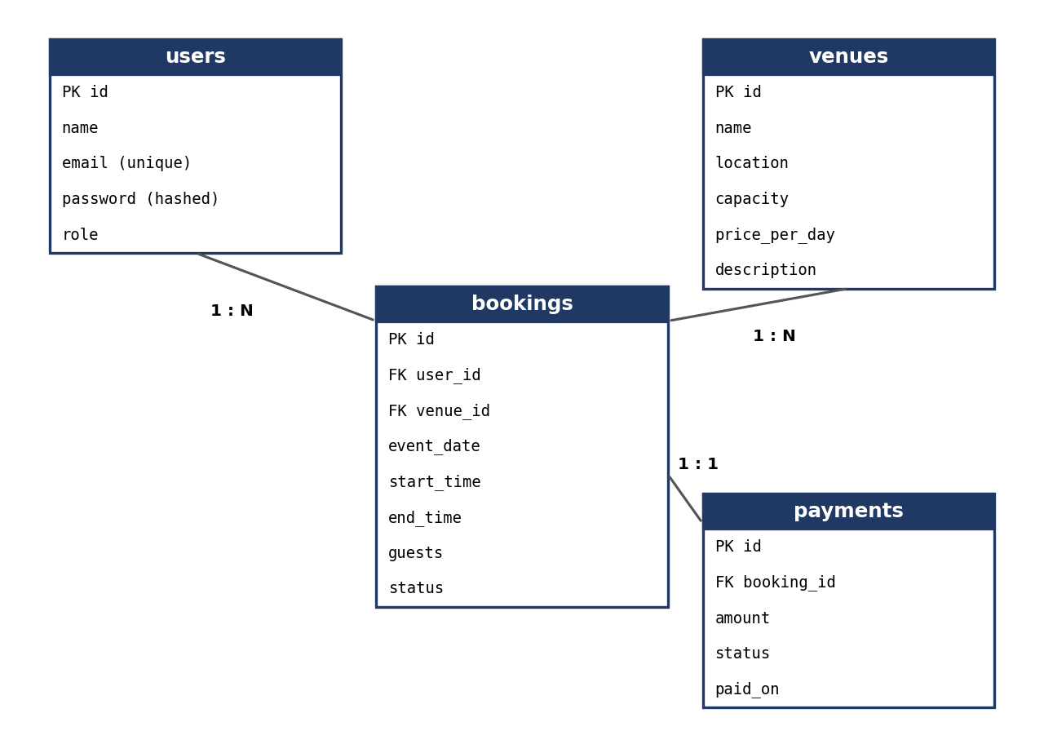
Figure 6.1: Entity-Relationship diagram

6.2 Use Case Summary
Actor | Use cases
Administrator | Log in; add, view, update and delete venues; view all bookings; confirm or cancel bookings; record payments
Customer | Register; log in; view venues; create a booking; view own bookings; cancel a booking

6.3 Context-Level Data Flow
External entity | Data into VMS | Data out of VMS
Administrator | Venue details, booking confirmations, payment records | Venue list, all bookings
Customer | Registration and login details, booking requests, cancellations | Venue list and details, own bookings with status, error messages (e.g. “venue already booked”)

6.4 Booking Validation Flow
- Receive venue, event date, start time, end time and number of guests.
- Reject with “invalid time range” if the end time is not after the start time (FR-3.2).
- Load the venue and reject the request if the guest count exceeds its capacity (FR-3.3).
- Look for a non-cancelled booking of the same venue and date that satisfies existing.start < new.end AND existing.end > new.start; if found, reject with “venue already booked” (FR-3.4).
- Otherwise save the booking with status PENDING and return it (FR-3.5).

7. Appendices

Appendix A: Requirement Traceability to Test Cases
The following cases from the project test plan verify the main requirements.
Test case | Scenario | Expected result | Requirement
TC-01 | Start the application | Server starts on port 8080 and connects to MySQL | NFR-1
TC-02 | Automatic table creation | Tables created in venue_db | Section 6.1
TC-03 | POST /api/venues with valid JSON | Venue saved and returned with a new id | FR-2.1
TC-04 | GET /api/venues/{id} with wrong id | Error: Venue not found | FR-2.5
TC-05 | Book a free time slot | Booking saved with status PENDING | FR-3.5
TC-06 | Book an overlapping time slot | Rejected: venue already booked | FR-3.4
TC-07 | End time before start time | Rejected: invalid time range | FR-3.2
TC-08 | Register with an existing email | Rejected: email already registered | FR-1.2
TC-09 | Admin confirms a booking | Status changes to CONFIRMED | FR-3.6

Appendix B: Future Enhancements (Out of Scope for v1.0)
- A complete frontend (React.js or Thymeleaf) for customers and administrators.
- Secure authentication with Spring Security, JWT tokens and BCrypt password hashing.
- Online payment integration (for example, Razorpay) with automatic booking confirmation.

Appendix C: Known Risks and Lessons Learned
- Build-path and dependency problems (project not recognised as Maven; parent POM not downloadable on a restricted network) – mitigated by importing as a Maven project and updating on an unrestricted network.
- Component scanning requires all packages under the main application package, and file names must match public class names.
- Correctly detecting every type of time overlap – solved with the single condition given in FR-3.4.

Appendix D: Approval
Role | Name | Signature | Date
Prepared by | Rajneekant Yadav
Project Guide
Head of Department, CSE

